Workflow

What is Workflow?
# Source: AI Source: Provided by: [Data Path: Persons Table -> ID Column: 1, Name_En Column: Motasem Essam] -> From: [ChatGPT] on [2/15/2026]
In Git, GitHub, or GitLab, a workflow is a structured process or sequence of steps that developers follow to manage, develop, test, and deploy code.
It defines how code changes move from your local machine to production, including commits, branches, pull/merge requests, reviews, CI/CD, and releases.

Key points
# Source: AI Source: Provided by: [Data Path: Persons Table -> ID Column: 1, Name_En Column: Motasem Essam] -> From: [ChatGPT] on [2/15/2026]
- Defines process
  - Workflow is not a command, it’s a strategy for collaboration
  - Helps teams work efficiently and consistently
- Scope
  - Can be individual workflow → how a single developer organizes commits and branches
  - Can be team workflow → includes branching rules, PR/MR review, testing, and deployment

Common Workflows
# Source: AI Source: Provided by: [Data Path: Persons Table -> ID Column: 1, Name_En Column: Motasem Essam] -> From: [ChatGPT] on [2/15/2026]
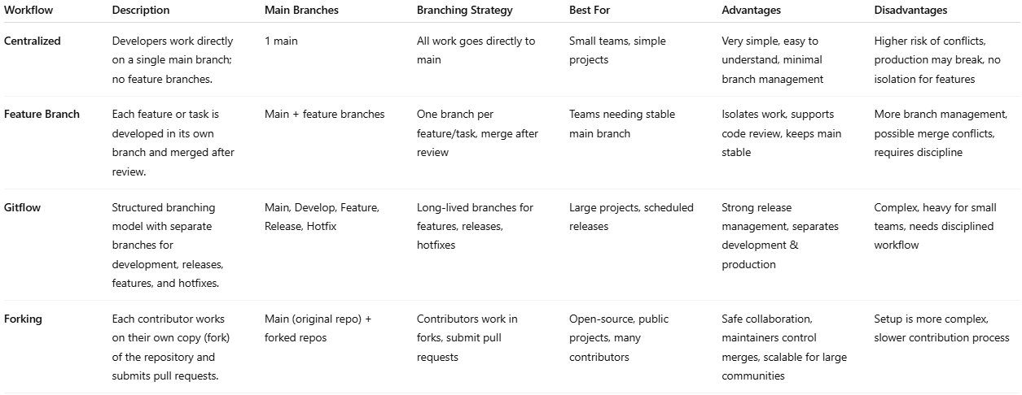
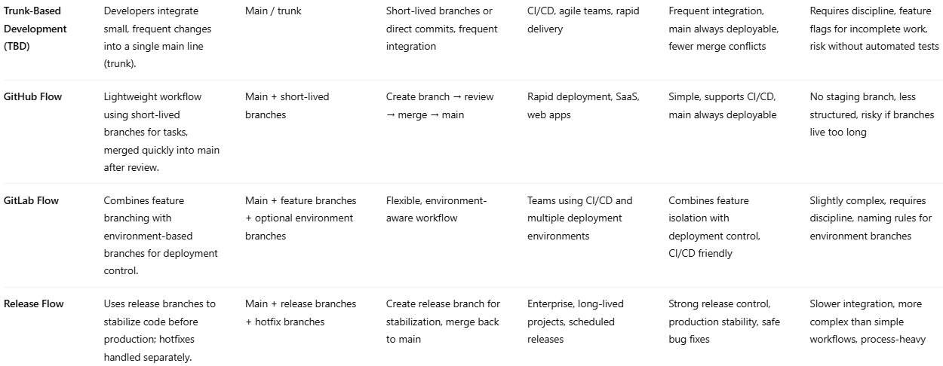

Workflow | Description | Main Branches | Branching Strategy | Best For | Advantages | Disadvantages
Centralized | Developers work directly on a single main branch; no feature branches. | 1 main | All work goes directly to main | Small teams, simple projects | Very simple, easy to understand, minimal branch management | Higher risk of conflicts, production may break, no isolation for features
Feature Branch | Each feature or task is developed in its own branch and merged after review. | Main + feature branches | One branch per feature/task, merge after review | Teams needing stable main branch | Isolates work, supports code review, keeps main stable | More branch management, possible merge conflicts, requires discipline
Gitflow | Structured branching model with separate branches for development, releases, features, and hotfixes. | Main, Develop, Feature, Release, Hotfix | Long-lived branches for features, releases, hotfixes | Large projects, scheduled releases | Strong release management, separates development & production | Complex, heavy for small teams, needs disciplined workflow
Forking | Each contributor works on their own copy (fork) of the repository and submits pull requests. | Main (original repo) + forked repos | Contributors work in forks, submit pull requests | Open-source, public projects, many contributors | Safe collaboration, maintainers control merges, scalable for large communities | Setup is more complex, slower contribution process
Trunk-Based Development (TBD) | Developers integrate small, frequent changes into a single main line (trunk). | Main / trunk | Short-lived branches or direct commits, frequent integration | CI/CD, agile teams, rapid delivery | Frequent integration, main always deployable, fewer merge conflicts | Requires discipline, feature flags for incomplete work, risk without automated tests
GitHub Flow | Lightweight workflow using short-lived branches for tasks, merged quickly into main after review. | Main + short-lived branches | Create branch → review → merge → main | Rapid deployment, SaaS, web apps | Simple, supports CI/CD, main always deployable | No staging branch, less structured, risky if branches live too long
GitLab Flow | Combines feature branching with environment-based branches for deployment control. | Main + feature branches + optional environment branches | Flexible, environment-aware workflow | Teams using CI/CD and multiple deployment environments | Combines feature isolation with deployment control, CI/CD friendly | Slightly complex, requires discipline, naming rules for environment branches
Release Flow | Uses release branches to stabilize code before production; hotfixes handled separately. | Main + release branches + hotfix branches | Create release branch for stabilization, merge back to main | Enterprise, long-lived projects, scheduled releases | Strong release control, production stability, safe bug fixes | Slower integration, more complex than simple workflows, process-heavy

Example: Feature Branch Workflow
# Source: AI Source: Provided by: [Data Path: Persons Table -> ID Column: 1, Name_En Column: Motasem Essam] -> From: [ChatGPT] on [2/15/2026]
- Create a branch for your feature:
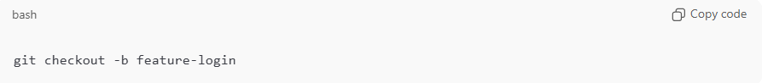
git checkout -b feature-login
- Work on your code and commit changes:
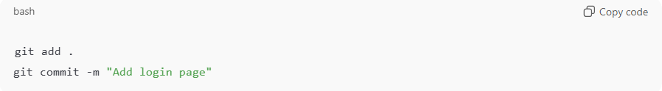
git add .
git commit -m "Add login page"
- Push branch to remote:
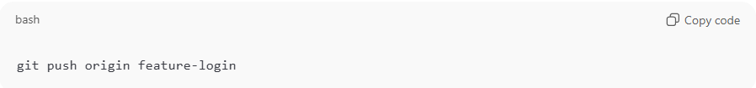
git push origin feature-login
- Open a Pull Request (GitHub) or Merge Request (GitLab)
- Code review and approval
- Merge into main branch
- CI/CD pipeline runs automatically → deploy to staging/production

Key idea
# Source: AI Source: Provided by: [Data Path: Persons Table -> ID Column: 1, Name_En Column: Motasem Essam] -> From: [ChatGPT] on [2/15/2026]
Workflow = a repeatable process for managing code changes
- Ensures consistency, quality, and collaboration
- Integrates branching, commits, PR/MR, review, CI/CD, and releases

💡 Memory trick:
# Source: AI Source: Provided by: [Data Path: Persons Table -> ID Column: 1, Name_En Column: Motasem Essam] -> From: [ChatGPT] on [2/15/2026]
Workflow = “step-by-step roadmap” for how code moves from idea → commit → review → merge → deployment ✅

